**Histogram Equalization**

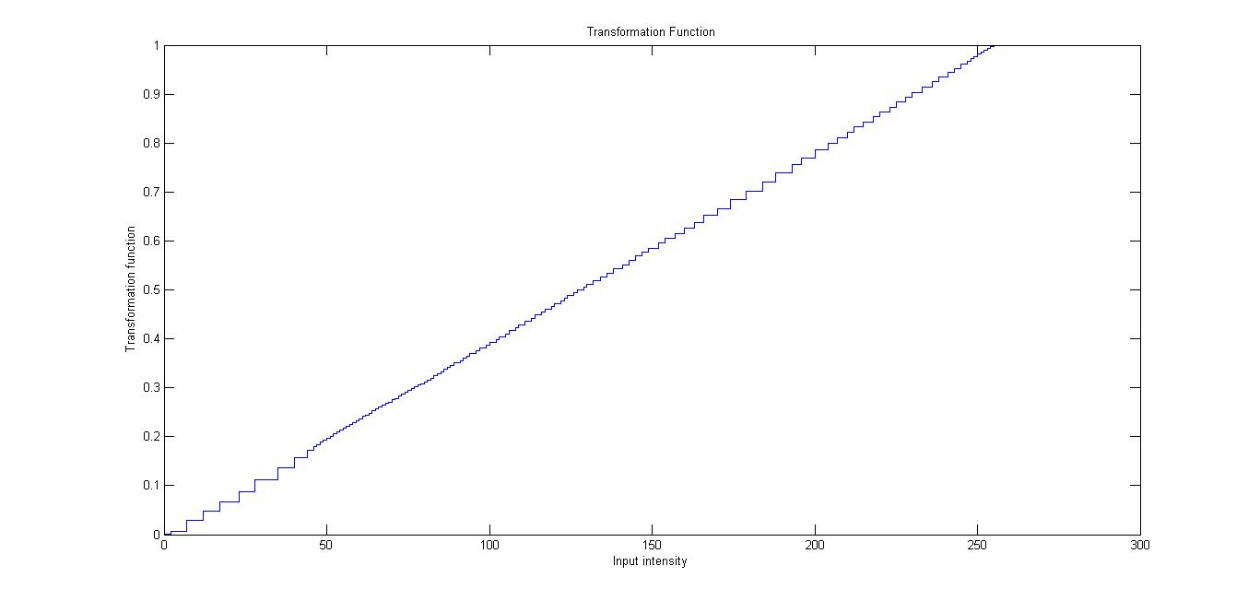

* The above shows the step function of how the input intensity values are mapped.

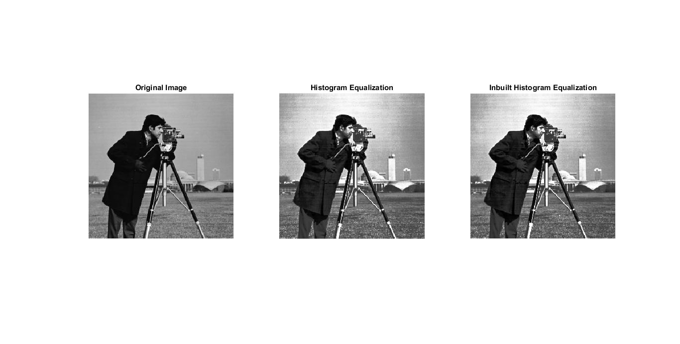

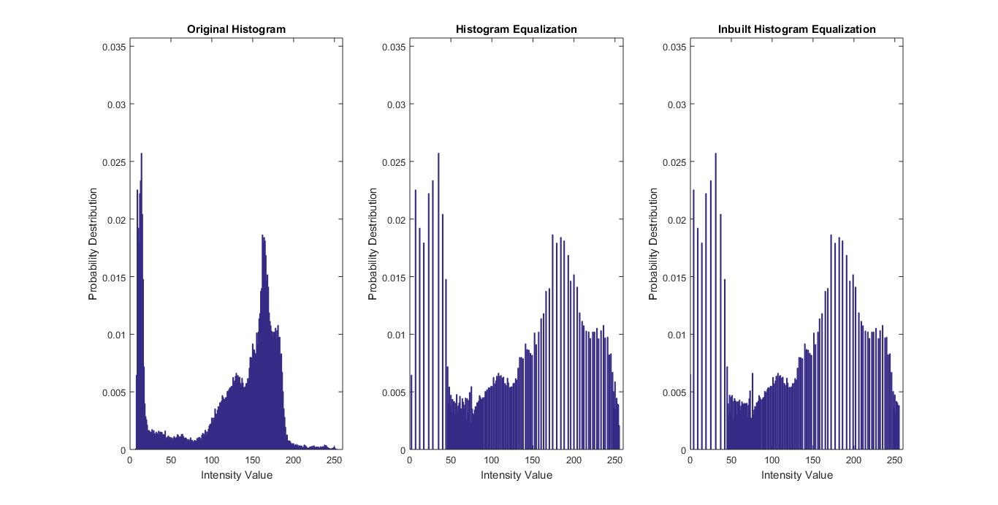

* The original histogram is dense within 100-200 pixel values and has less pixel intensity values from 200-255.
* We observe that the histogram shape changes after equalization and is more uniform than previously.
* Also, the histogram after equalization is very similar to the inbuilt histogram equalization.
* We observe the RMSE of 1.7001 from the inbuilt histogram equalization.